**Design Challenge 5**

**Electronic Design Notebook**

**Team 45**

Kathryn Atherton

Joshua Hahn

Hannah Mackin Schenck

**Brainstorming and Problem Exploration**

Assumptions and Known Requirements

* Parallelogram shape
* Walkways should be 10 feet wide
* Sides should rise 5 feet above the walkway
* Do not need to consider deck cost or design
  + Assume 6 in thick, made of concrete with density of 150 lbf/ft3
* Weight of pedestrians modeled as uniform load with value of 85 lbf/ft3
  + Consider pedestrians filling 100%, 50%, 25% of length
  + Consider where 50%, 25% along bridge to apply loads
* Do not need to consider lateral bracing, struts, secondary bracing
* Assume truss members are flat bars with rectangular cross-sections
* Do not need to consider stairs to walkway
* 2.5 Factor of Safety against failure
* Need to account for when people are going to/leaving football/basketball games
* Be sure all buses and trucks can safely run underneath walkway
  + At least 14 feet high
* Design Idea: Make trusses look like Engineering Fountain

**Model Descriptions**

Figure 1: Model of Bridge Location



Figure 2: Model of Side of Bridge Design

Figure 3: 3D Representation of Bridge Design

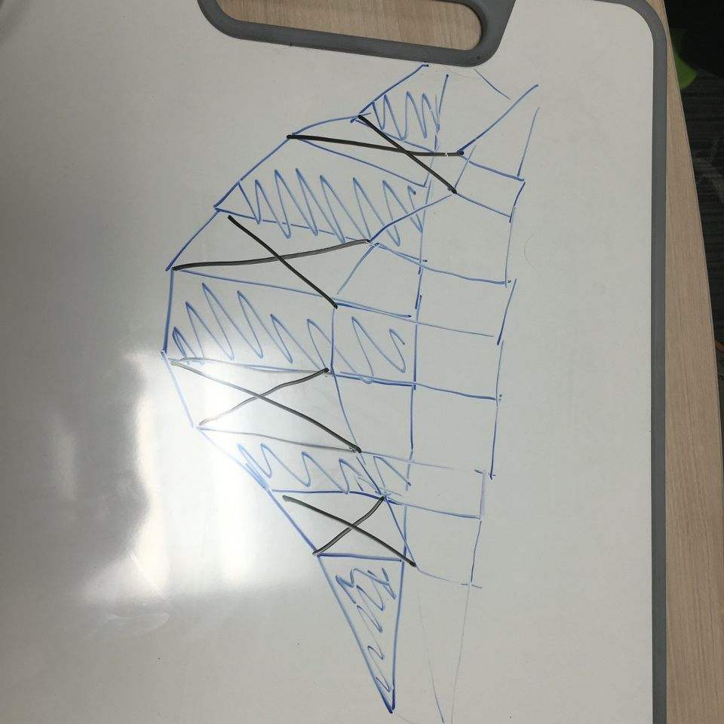

Figure 4: Representation of Forces on Bridge

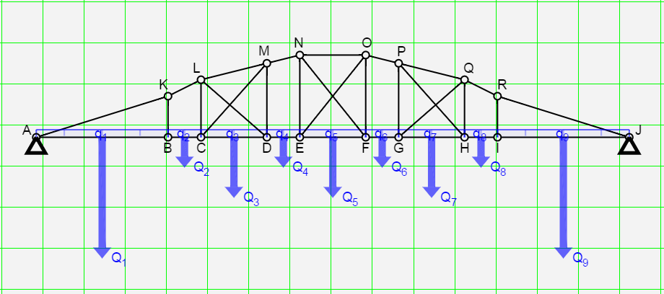

Figure 5: Individual Points Free Body Diagram

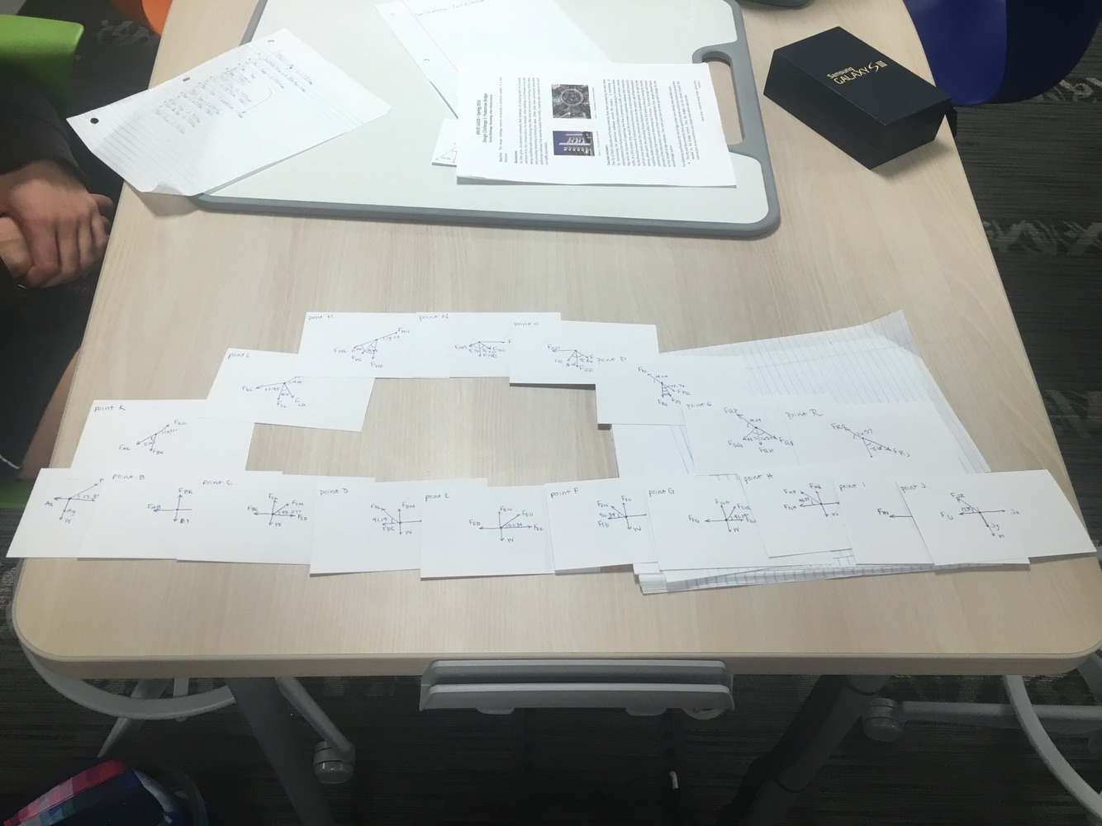

**Decision Matrices**

Table 1: Decision Matrix of Materials

